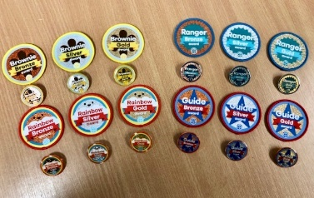
TOP AWARDS ORDER FORM
Please complete the boxes below and post to Girlguiding Worcestershire, County Office, Acre Lane, Droitwich, Worcs. WR9 9BE with a cheque made payable to Worcestershire Guide Association OR email this completed form to badges@girlguidingworcs.org.uk if wishing to pay by BACS or collecting.
Name of Unit_______________________________________________
NAME OF LEADER
UNIT/DIVISION/SECTION |  | RAINBOW/BROWNIE/GUIDE/RANGER  Please circle
ITEMS REQUIRED  Please enter quantity | WOVEN BADGE £1.20  Bronze:  Silver:  Gold: | METAL BADGE £2.25  Bronze:  Silver:  Gold: | CERTIFICATE 80P  Bronze:  Silver:  Gold:
TOTAL | £ | £ | £
Please tick all boxes that apply

I ENCLOSE A CHEQUE FOR £ payable to Worcestershire Guide Association (including P&P as below if applicable)

I HAVE PAID BY BACS – WORCS GUIDE ASSOC – SORT CODE:30-99-90 ACCOUNT NO:02042628
REFERENCE TOP AWARDS

I WISH TO COLLECT THIS ORDER FROM THE COUNTY OFFICE BY PRIOR ARRANGEMENT

I WISH THIS ORDER TO BE POSTED TO (add address below)

P&P: woven badge & certificates only - £1.50

all badges and certificates and large orders £3.00)

Address if posting is required:-………………………………………………………………………………………………………………………………………..…

……………………………………………………………………………………………………………………………….………….
……………………………………………………………………………………………………………………………………………

