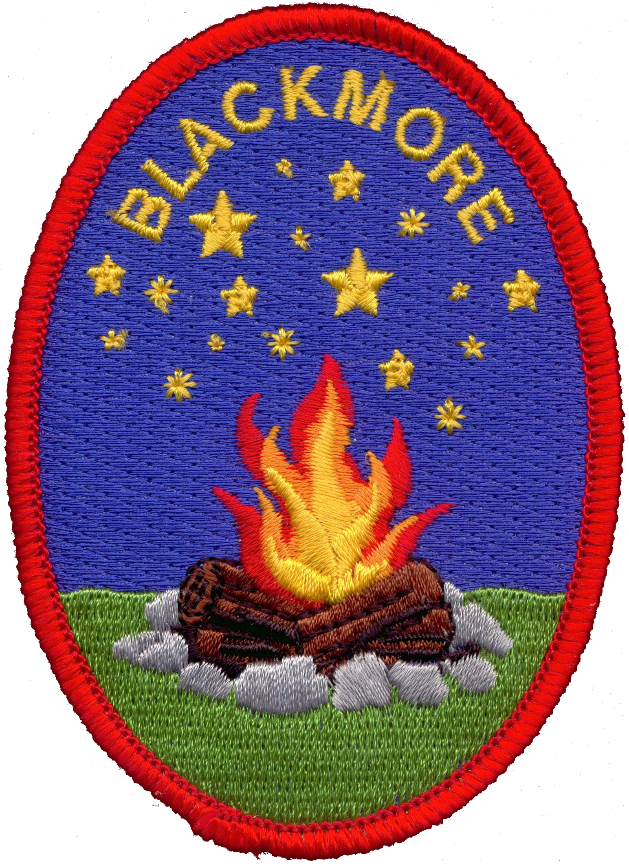

Risk Assessment for

The Rambler

Blackmore Campsite Worcestershire

|  |  |  |  |  |  |
| --- | --- | --- | --- | --- | --- |
| **Hazard** | **Risk** | **Who is affected?** | **Risk Level** | **Prevention** | **Re-view Date** |
| Floors | Slips  Trips  And Falls | Hirers/Parents and Visitors | H | Ensure lighting is in good working order.  Hirer to wear appropriate footwear.  Spillages must be moped up immediately.  Use yellow Signs to notify Girls. |  |
| **Main Room** |  |  |  |  |  |
| Cleaning Products | Ingestion  Inhalation  Skin  Irritation | Hirer/Girls | H | Keep all cleaning products in lockable cage provided (under sink) when not in use.  Use Gloves.  If Girls are using Cleaning products adults’ supervision at all times. |  |
| Fire Exit Doors | Trapped in Building | Hirer/Girls | H | Ensure that the hirer keeps the exit doors unlocked while on site.  Ensure that no items are left in front of Exits doors at all times. |  |
| Furniture | Injury to fingers | Hirer/Girls | M | Ensure that adults supervise when bed furniture is being pulled out and put away. |  |
| Tables | Injury to  Fingers | Hirer/Girl | M | Ensure that Girls are supervised when opening and closing table legs. |  |
| Chairs | Injury to  Fingers  Falls | Hirer/Girls | M | Ensure that Girls don’t swing on chairs.  Care to be taken when storing the chairs. |  |
| Hot water | Spread of infection    Burns | Hirer/Girls | M | Ensure that water temperature is checked regular.  When pouring boiling water from Kettle make sure that is sufficient space available. |  |
| Electric Oven | Burns | Hirer/Girls | H | Use oven gloves provided  Ensure that the girls know what the dangers are in this area. |  |
| Kitchen Equipment | Injury | Hirer/Girls | H | For some equipment Adult supervision will be needed. |  |
| Hirers or Girls  Luggage | Trips  Slips  And Falls | Hirers/Girls | M | Ensure Hirer lets their Girls know that must not leave Luggage on the floor which routes to fire exits. |  |
| Electric Wall Heater | Burns | Hirers/Girls | M | Advise hirer not to cover the heaters. |  |
| **Storage Area** |  |  |  |  |  |
| House Equipment  Storage space. | Injury | Hirer/Girls | L | Hirer to ensure area is tidy at all times. |  |
| **Wet Room**  **Bathrooms** |  |  |  |  |  |
| Sinks/Toilet | Spread of infection | Hirer/Girl | M | Ensure these are checked regular during groups stay.  Advise that a housework rota should be place during their stay.  Adults’ supervision suggested if girls are helping with cleaning. |  |
| Shower | Spread of infection | Hirer/Girls | M | Ensure water temperature is checked regular basics. |  |
| **Adult Bedroom** |  |  |  |  |  |
| Bunk bed  Ladder | Injury | Hirer | M | Ensure that footwear is used when climbing ladder to top bunk. |  |
| **Extras** |  |  |  |  |  |
| Set Ladder | Injury | Hirer | H | Hirer to discourage girls from using step ladder.  When using step ladder it is a two man job. |  |