
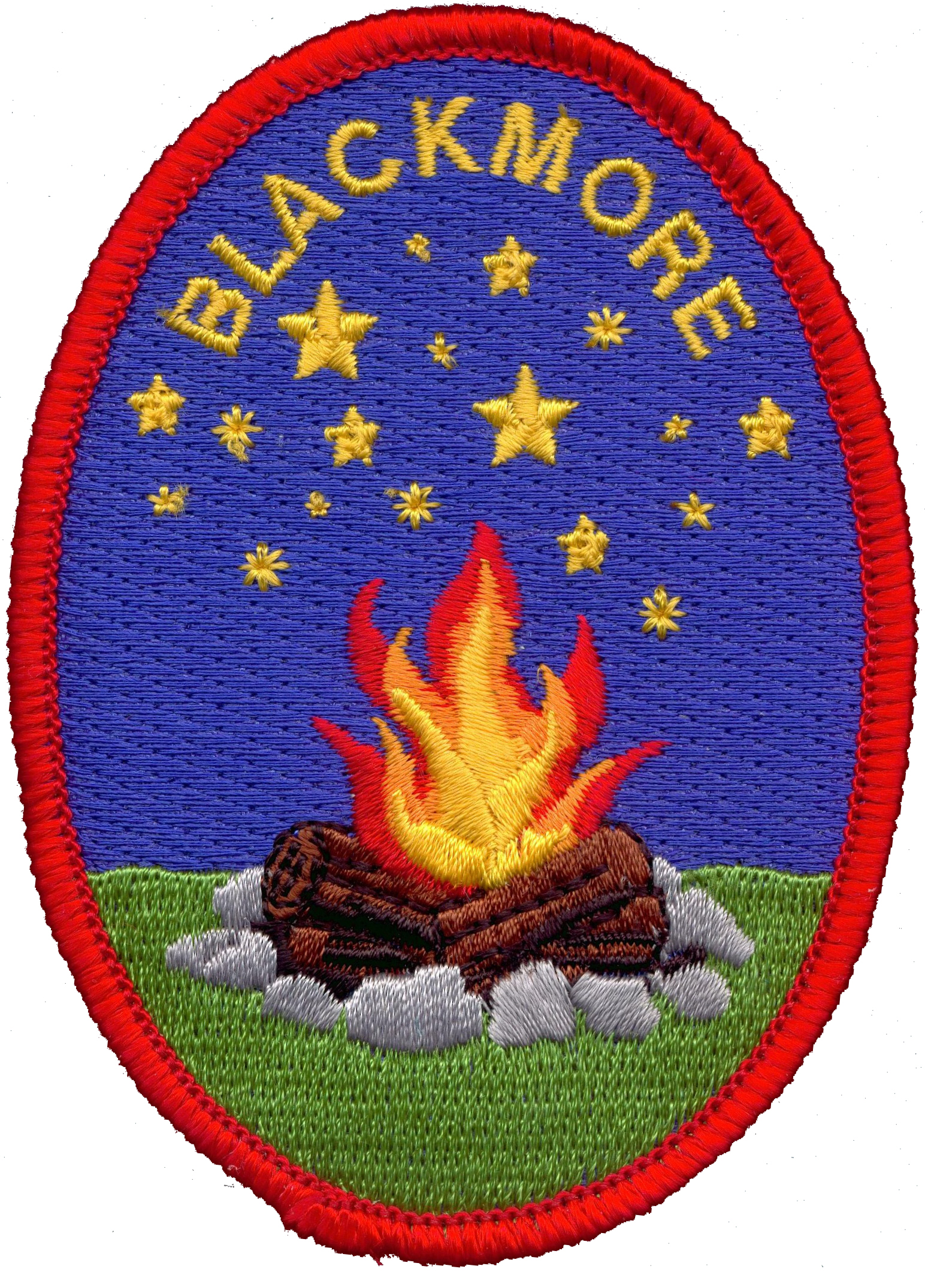
Risk Assessment for
The Rambler
Blackmore Campsite Worcestershire

Hazard | Risk | Who is affected? | Risk Level | Prevention | Re-view Date
Floors | Slips  Trips  And Falls | Hirers/Parents and Visitors | H | Ensure lighting is in good working order.  Hirer to wear appropriate footwear.  Spillages must be moped up immediately.  Use yellow Signs to notify Girls.
Main Room
Cleaning Products | Ingestion  Inhalation  Skin  Irritation | Hirer/Girls | H | Keep all cleaning products in lockable cage provided (under sink) when not in use.  Use Gloves.  If Girls are using Cleaning products adults’ supervision at all times.
Fire Exit Doors | Trapped in Building | Hirer/Girls | H | Ensure that the hirer keeps the exit doors unlocked while on site.  Ensure that no items are left in front of Exits doors at all times.
Furniture | Injury to fingers | Hirer/Girls | M | Ensure that adults supervise when bed furniture is being pulled out and put away.
Tables | Injury to  Fingers | Hirer/Girl | M | Ensure that Girls are supervised when opening and closing table legs.
Chairs | Injury to  Fingers  Falls | Hirer/Girls | M | Ensure that Girls don’t swing on chairs.  Care to be taken when storing the chairs.
Hot water | Spread of infection  Burns | Hirer/Girls | M | Ensure that water temperature is checked regular.  When pouring boiling water from Kettle make sure that is sufficient space available.
Electric Oven | Burns | Hirer/Girls | H | Use oven gloves provided  Ensure that the girls know what the dangers are in this area.
Kitchen Equipment | Injury | Hirer/Girls | H | For some equipment Adult supervision will be needed.
Hirers or Girls  Luggage | Trips  Slips  And Falls | Hirers/Girls | M | Ensure Hirer lets their Girls know that must not leave Luggage on the floor which routes to fire exits.
Electric Wall Heater | Burns | Hirers/Girls | M | Advise hirer not to cover the heaters.
Storage Area
House Equipment  Storage space. | Injury | Hirer/Girls | L | Hirer to ensure area is tidy at all times.
Wet Room
Bathrooms
Sinks/Toilet | Spread of infection | Hirer/Girl | M | Ensure these are checked regular during groups stay.  Advise that a housework rota should be place during their stay.  Adults’ supervision suggested if girls are helping with cleaning.
Shower | Spread of infection | Hirer/Girls | M | Ensure water temperature is checked regular basics.
Adult Bedroom
Bunk bed  Ladder | Injury | Hirer | M | Ensure that footwear is used when climbing ladder to top bunk.
Extras
Set Ladder | Injury | Hirer | H | Hirer to discourage girls from using step ladder.  When using step ladder it is a two man job.

