
FRIENDS OF BLACKMORE
Always raising funds for our County Campsite

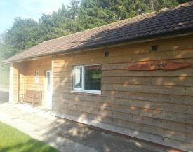
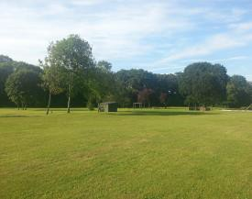
There are other ways of supporting Blackmore …
Friends of Blackmore
We were founded with one simple aim – to raise funds to support Blackmore - Girlguiding Worcestershire’s very own beautiful camp site in the shadow of the Malvern Hills.
It was realised that there were members, retired members, and friends of Guiding who wanted to support Blackmore in some small way but who didn’t want to spend lots of time raising money – after all we’re all busy people.
Support us for just £5
You can support Blackmore by simply becoming a member of Friends of Blackmore for just £5 a year.
There are two others ways of supporting Blackmore:
Join our 200 Club and win cash prizes
or
Enjoy any of our two social events held every year.

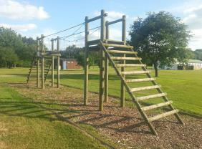
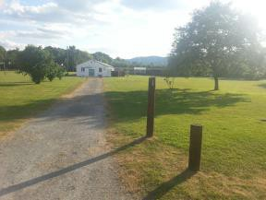
200 Club
For just £1 a month (that’s £12 a year) you will be allocated a number that goes into a monthly draw for a cash prize.
There are 2 draws every year for £50 and 10 draws for £30.
All you have to do is complete this form, then sit back and wait. We’ll let you know when you’ve won.

Annual Lunch & Quiz Night
We organise two social events every year for Friends of Blackmore and guests are also very welcome.
The Annual Lunch is an informal meal, held on a weekend in January or February at a local hotel.
Our Quiz Night is a fun evening held in the summer usually at Blackmore, and includes a delicious supper.

For more information about Friends of Blackmore:
Hundreds of children and young people enjoy the facilities & activities at Blackmore every year, whether it’s camping, overnight stays or day trips.
Tel: 01905 797377
E-mail: fob@girlguidingworcs.org.uk
Web: www.girlguidingworcs.org.uk/friends-of-blackmore
Electronic version


FRIENDS OF BLACKMORE
Always raising funds for Blackmore, our County Campsite

Membership and 200 Club Application

Bank Mandate

Toinsert your bank

Address: ………………………………………………………………………………………

………………………………………………………………………………………………………..

Name on your account: ……………………………………………………………
Sort Code: ………………
Account number: ………………………………….
Please pay to the credit of Friends of Blackmore, Worcestershire Guide Association, Lloyds Bank plc, Worcester, WR1 3PY
Sort Code 30-99-90 Account No.01727554
the sum of *£5.00/£12.00/£17.00immediately and thereafter annually until further instructions are given. *please delete as appropriate

Name: (please print) ……………………………………………………………..

Signed: ………………………………………………………………………………..

Date: ……………………………
Name:
Address:

Tel No: E-mail:

Subscription

Please tick one box

Friends of Blackmore Membership 200 Club
Friends of Blackmore & 200 Club
£5.00 per year
£12.00 per year
£17.00 per year

I would like Friends of Blackmore to treat my membership subscription and any donations I may make as a Gift Aid donation. I confirm that I pay income tax equal to 20% of the subscription. (Please delete if necessary)

Please return to our Membership Secretary: Laura Flecknell, 7 Westlea Close, Worcester. WR2 5UH
Or scan and e-mail to: FOB@girlguidingworcs.org.uk
If you would prefer to pay by cheque, please make it payable to Friends of Blackmore (Worcestershire Guides)

