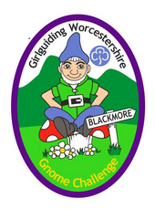

Order Form

**Gnome Challenge Badge**

Unit:

|  |  |  |  |
| --- | --- | --- | --- |
| **Badge** | **Quantity** | **Price** | **Total** |
| Gnome Challenge |  | £1 each |  |
|  |  | P & P |  |
| **TOTAL** | | | £ |

*Cheques payable to: Worcestershire Guide Association*.

BACS payments to Worcestershire Guide Association

SORT CODE:30-99-90 ACCOUNT NO:03255099 REFERENCE:GNOME BADGES

How do you want to receive your order?

Collect from Blackmore Shop / Collect from County Office / Post

Please send to: ___________________________________________________

_________________________________________________________________

Date required for: _____/_____/_____

***Office use only***

*Received: _______________________ Sent: _______________________*