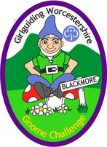

BLACKMORE
GNOME CHALLENGE
ORDER FORM

UNIT ____________________________________________________________

BADGE | QUANTITY | PRICE | TOTAL
GNOME BADGE |  | £1.00
 |  | P & P
TOTAL

Cheques payable to GG BLACKMORE SHOP

How would you like to receive your order?
Collect from: Blackmore Shop / Collect from the county office / Post out to you.

Please send to : _______________________________________ Post Code __________

Date Required: ________________________________________
Office use only
Received _____________________________ Sent __________________________

