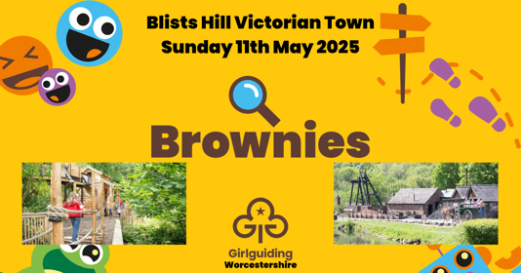
GIRLGUIDING WORCESTERSHIRE
COUNTY BROWNIE DAY
at Blists Hill Victorian Town
FINAL BOOKING FORM
Unit Name
Main Contact Name
Email address
Contact telephone no.
Number of Brownies @ £15.00 |  | £
Number of Leaders/Adults (in ratio 1:8) FREE OF CHARGE
Number of extra Leaders, Helpers @ £10 |  | £
Number of YLs @ £10.00 |  | £
TOTAL AMOUNT TO PAY |  | £
Method of travel

Please detail any allergies, dietary or extra requirements for any of your participants

Please return the completed form and either send it by post with your cheque payable to Worcestershire Guide Association to Girlguiding Worcestershire County Office, Acre Lane, Droitwich, Worcs. WR9 9BE or pay by BACS (Worcs Guide Assoc Sort Code 30-99-90 Account No 02042628 Reference BROWNDAY) and email it to office@girlguidingworcs.org.uk by Monday 31 March

THANK YOU

