Severn & Teme Division

2020 was a challenging year for everyone but units from each of the sections within Severn & Teme refused to allow the pandemic to dampen the Guiding spirit! Many leaders adapted to new ways of communicating through virtual meeting platforms such as a Zoom and Facebook Live as well as taking advantage of the lovely spring and summer weather by having socially distanced outdoor meetings.

Before lockdown in March several units from the Division joined the Midlands Region Celebrate event at the NEC in February. An amazing and enjoyable experience for us all. Brownies and Guides managed to fit in a trip to the local Pantomime. There were fundraising beetle drives and car boot sales. Guides and Rangers stayed at Pax Lodge and competed in the Monopoly run, some members seeing London sights for the first time. They also visited 10 Downing Street before the journey home. One Guide unit started the year by doing the Amey Challenge badge. A lot of fun was had, dropping eggs from great heights in homemade parachutes and making dodecahedrons from sweets and cocktail sticks to name just a couple of the activities. For all sections, evenings were jam packed from January to March celebrating Chinese New Year, murder mystery and themed Parties to mention just a few. There was also a trip to the Tamworth Snow Dome and watching lambing at a local farm.

Whenever possible, Rainbows met together and continued with their skills builder challenges, interest badges and unit meeting activities. With lockdown, leaders took bags of resources and challenge information to the girls in their own homes. Rainbow and Brownie friends started meeting virtually on Zoom and completed household scavenger hunts, played games, learned new skills like pumpkin carving and made crafts. They enjoyed an indoor bonfire, making edible bonfires!

Lockdown in March did not stop the Brownies. They were as busy as ever being challenged at home to try interest badges like Zero Waste. The girls have also been able to continue working towards adapted skills builders and UMA's. Using their Facebook page, the girls were able to submit all their work and achievements and soon badge totals began to build up. They have attempted Paw Print, COVID19 and Blackmore 50 challenges. They have had virtual sleepovers, played silly games and held a family Christmas quiz with bingo evening. One unit ended each term with a virtual awards ceremony for girls and their parents.

Guides and Rangers began the year planning skills builders and UMA’s. But lockdown meant a change in how these plans would be implemented.
Leaders have supported girls to complete their Investigating interest badge in virtual meetings. They have also completed the Reflect skills builder, have made lava lamps, carved pumpkins, practiced origami, held scavenger hunts and created 3D snowflake decorations. They have played a multitude of games from wink murder and socially distanced splat to online scavenger hunts and quizzes. They have used the Adventures at home activities, joined The Forensic Experience and completed interest badges like Upcycling and Guiding Traditions. In a final Zoom Meeting of the summer term, one unit had a Beach Party and were visited by Simone the Goat!
VE Day was celebrated by decorating homes and one Guide stood with her father and grandmother outside their house with the British Legion Standard. Guides have completed the Silver award and two have complete Gold.

In the two gaps between lockdowns Guides decorated poppy stones which bore the names of local fallen heroes. The stones were laid in a special area in the churchyard. Another unit held an outdoor table sale and made nearly £300 towards the upkeep of their hut. A second sale nearer to Christmas raised nearly £600. 50% of this went to St Michael's hospice and the other 50% was split between the three sections in the village. A unit joined a local litter pick and also met at the Wyre Forest Centre.
Where a unit decided not to meet virtually, they held weekly cooking challenges, sending photos of their creations to their leader. And, of course, we all stood on our doorsteps, once a week, to clap the NHS.
The leaders are so proud of all their members and the support given by parents and are looking forward to being able to meet up again very soon.

Leaders and unit helpers from each section within Severn & Teme finished off the year with a virtual Silly Social Christmas party, complete with party games, a favourite tipple, an interesting assortment of hats and festive headwear, and true Girlguiding spirit.

This hasn’t been the best of years to start something new but we did, changing from District Commissioners to Team Leaders. The TLs have done an amazing job in the most difficult of times, for which we are most grateful. Our executive also grew with two new advisers to steer us forward. The Division has seen five new leaders qualify, presented five and ten long service awards, and acknowledged one 20, one 30, three 40 and one 50 long service awards.

Joining together has been a recurring theme this year so our hope to get to know each other better, when we first changed to Team Leaders, has certainly been achieved. Showing support for each is what guiding is all about. It has been amazing to hear about all the innovative ways leaders have shared and supported each other with activities and skills, both between units and between sections.

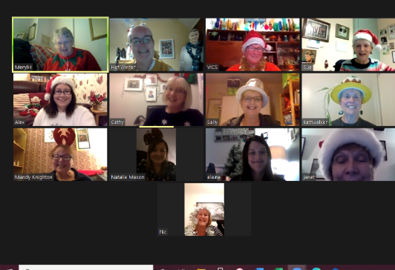
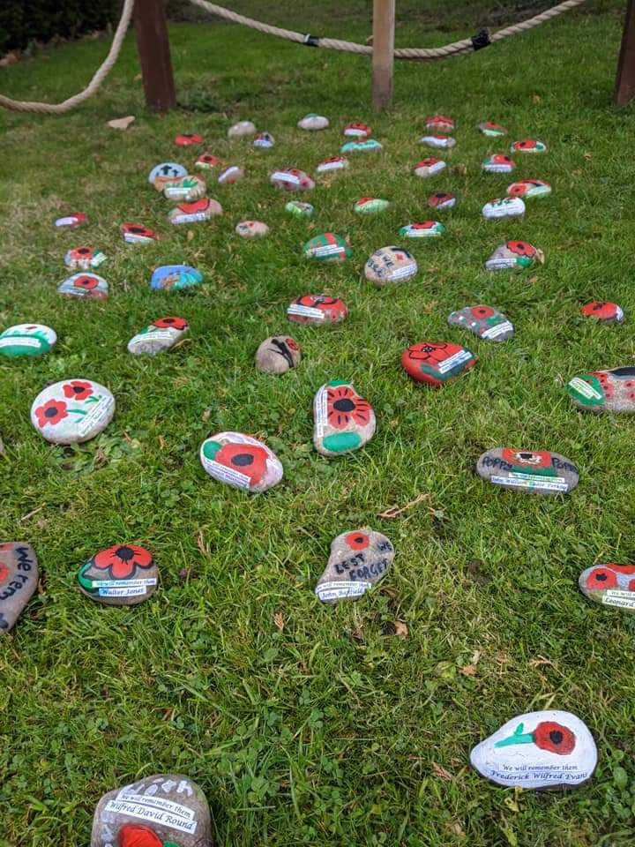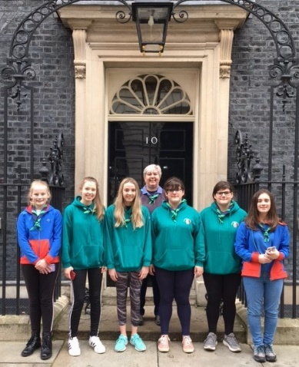
Poppy stones 10 Downing Street Christmas Silly Social

Kath Walker & Sue Crowther
Severn & Teme Division Commissioners

